**Fun Facts:**

**What are the insect’s lifecycle stages?**

**Insect Name:**

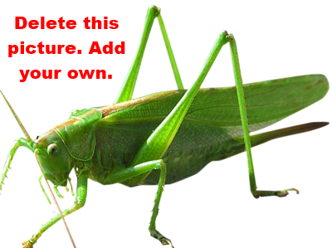

**My picture of the insect:**

**Where does this insect live?**

**Is this insect helpful or harmful to humans? Why?**

**Dylan’s Insect Research**